Bash Scripting – DevOps Practical Tasks
Objective: Create Bash scripts for common DevOps administration tasks including directory management, file creation and backup, NGINX and Tomcat installation, service monitoring, and CPU, disk, and memory monitoring.

Prerequisites
- Linux system such as Ubuntu or Amazon Linux.
- A user with sudo privileges.
- Internet connectivity for package installation.
- Basic Bash scripting knowledge.
- For email alerts, a working mail utility and configured mail service.

1. Check if a Directory Is Available
Script file: check_directory.sh
Purpose: The -d test checks whether the specified path exists and is a directory.
#!/bin/bash
DIR="/home/ec2-user/test"
if [ -d "$DIR" ]
then
echo "Directory exists: $DIR"
else
echo "Directory does not exist: $DIR"
fi
Execute: chmod +x check_directory.sh 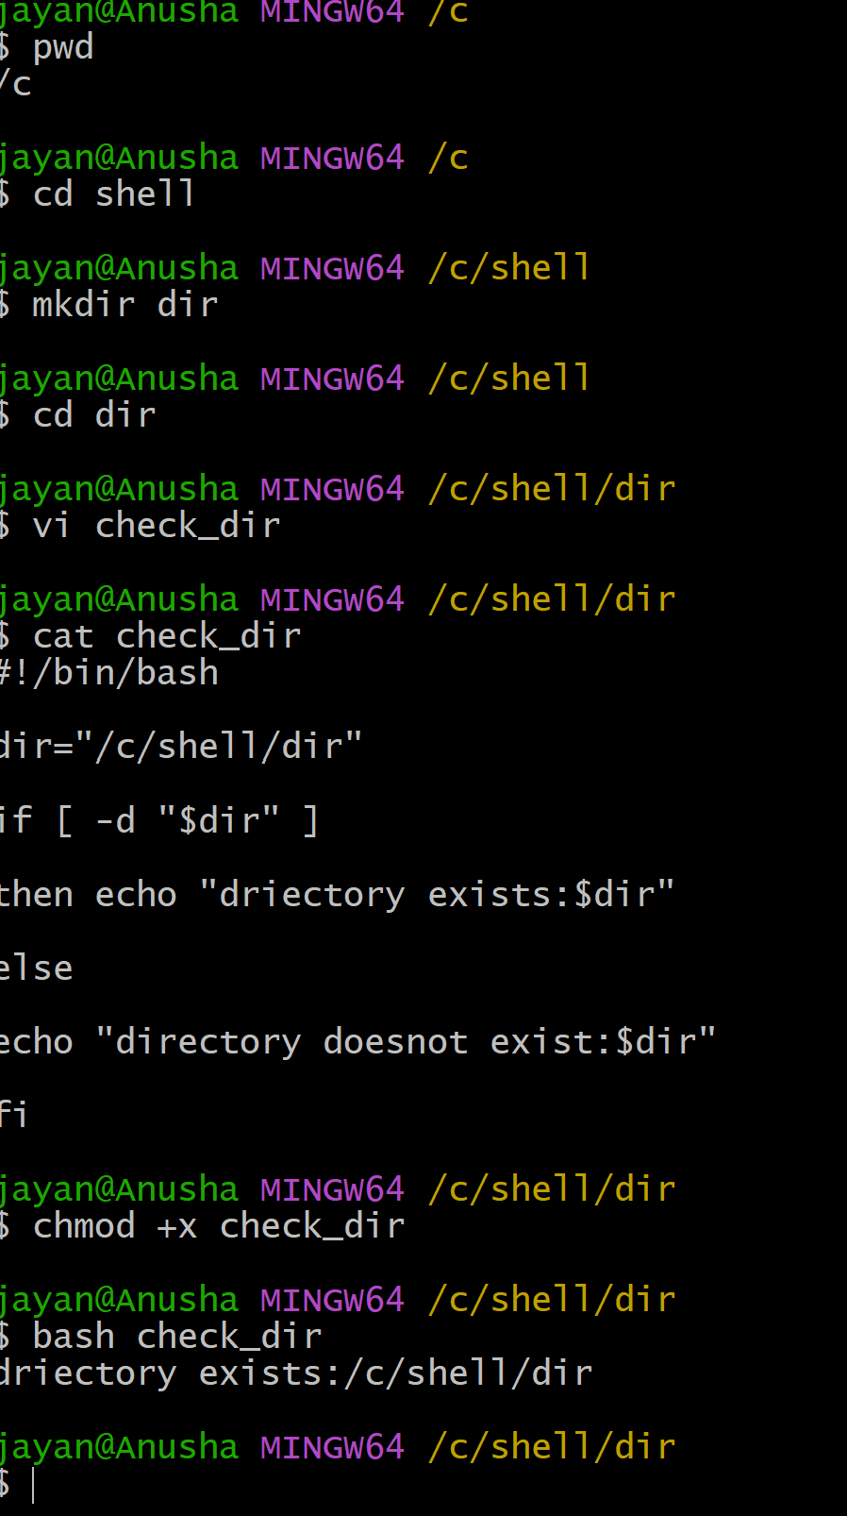
Run: ./check_directory.sh

2. Create Multiple Files
Script file: create_files.sh
Purpose: The script creates a directory if needed and creates five files using a for loop.
#!/bin/bash

thursday="/c/shell"

mkdir -p "$thursday"

for i in {1..6}

do
touch "$thursday/file$i.txt"

echo "created $thursday/file$i.txt"

done

echo "all files created sucessfully"

Execute: chmod +x create_files.sh
Run: ./create_files.sh 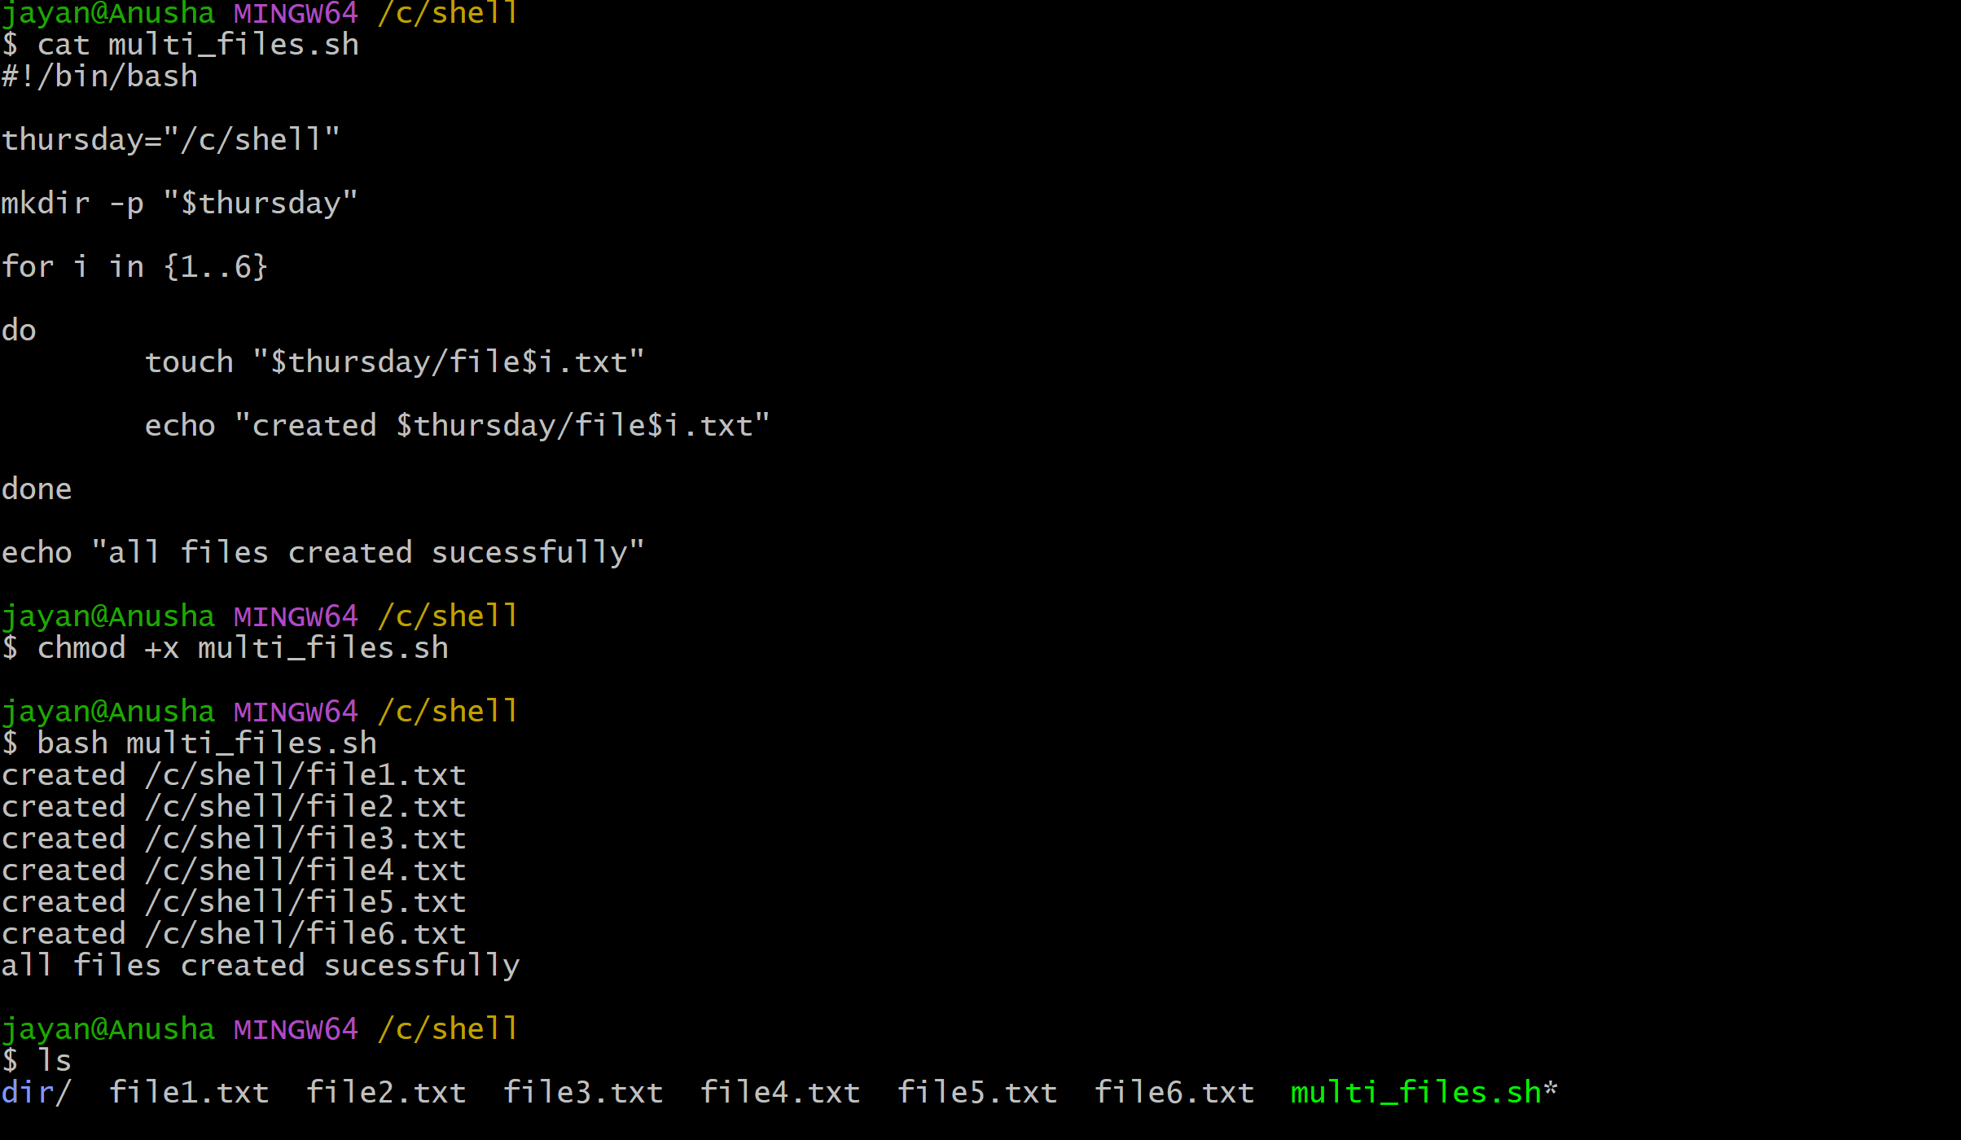

3. Take a Backup of a Directory
Script file: backup_directory.sh
Purpose: The tar command creates a compressed backup archive with a timestamped filename.
#!/bin/bash

SOURCE="/c/users/jayan/laxman/test"
BACKUP_DIR="/c/users/jayan/laxman/Backup"
DATE=$(date +"%Y-%m-%d_%H-%M-%S")

mkdir -p "$BACKUP_DIR"

tar -czf "$BACKUP_DIR/data_$DATE.tar.gz" "$SOURCE"

if [ $? -eq 0 ]
then
echo "Backup completed successfully."

echo "Backup file: $BACKUP_DIR/data_$DATE.tar.gz"
else
echo "Backup failed."
fi

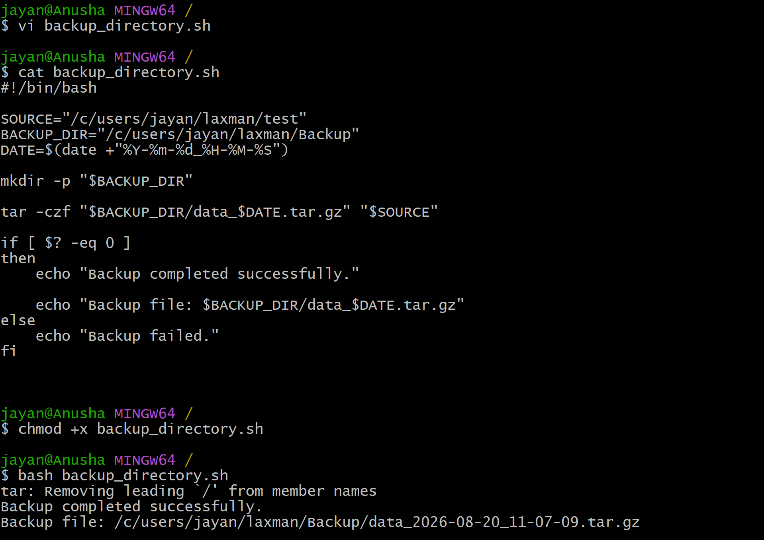

4. Install NGINX on an EC2 Server
Script file: install_nginx.sh
Purpose: This example is for Amazon Linux systems using dnf. It updates packages, installs NGINX, starts it, and enables it at boot.
#!/bin/bash
echo "Updating packages..."
sudo dnf update -y
echo "Installing NGINX..."
sudo dnf install nginx -y
echo "Starting NGINX..."
sudo systemctl start nginx
echo "Enabling NGINX at boot..."
sudo systemctl enable nginx
echo "Checking NGINX status..."
sudo systemctl status nginx --no-pager
Execute: chmod +x install_nginx.sh
Run: ./install_nginx.sh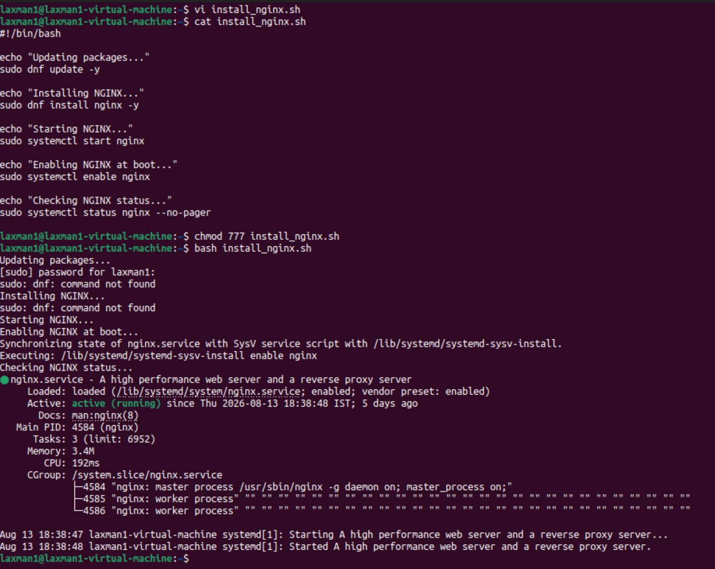

5. Install Apache Tomcat on an EC2 Server
Script file: install_tomcat.sh
Purpose: This example installs Java, downloads Tomcat, extracts it, makes startup scripts executable, and starts Tomcat. Verify the current Tomcat version and download URL before use.
#!/bin/bash
TOMCAT_VERSION="10.1.57"
TOMCAT_DIR="/opt/tomcat"
TOMCAT_URL="https://dlcdn.apache.org/tomcat/tomcat-10/v${TOMCAT_VERSION}/bin/apache-tomcat-${TOMCAT_VERSION}.tar.gz"
echo "Installing Java..."
sudo dnf install java-17-amazon-corretto -y
echo "Creating Tomcat directory..."
sudo mkdir -p "$TOMCAT_DIR"
cd /tmp || exit 1
echo "Downloading Tomcat..."
wget "$TOMCAT_URL" -O "apache-tomcat-${TOMCAT_VERSION}.tar.gz"
echo "Extracting Tomcat..."
sudo tar -xzf "apache-tomcat-${TOMCAT_VERSION}.tar.gz" -C "$TOMCAT_DIR"
sudo ln -sfn "$TOMCAT_DIR/apache-tomcat-${TOMCAT_VERSION}" "$TOMCAT_DIR/current"
sudo chmod +x "$TOMCAT_DIR/current/bin/"*.sh
echo "Starting Tomcat..."
sudo "$TOMCAT_DIR/current/bin/startup.sh"
echo "Tomcat installation completed."
Execute: chmod +x install_tomcat.sh
Run: ./install_tomcat.sh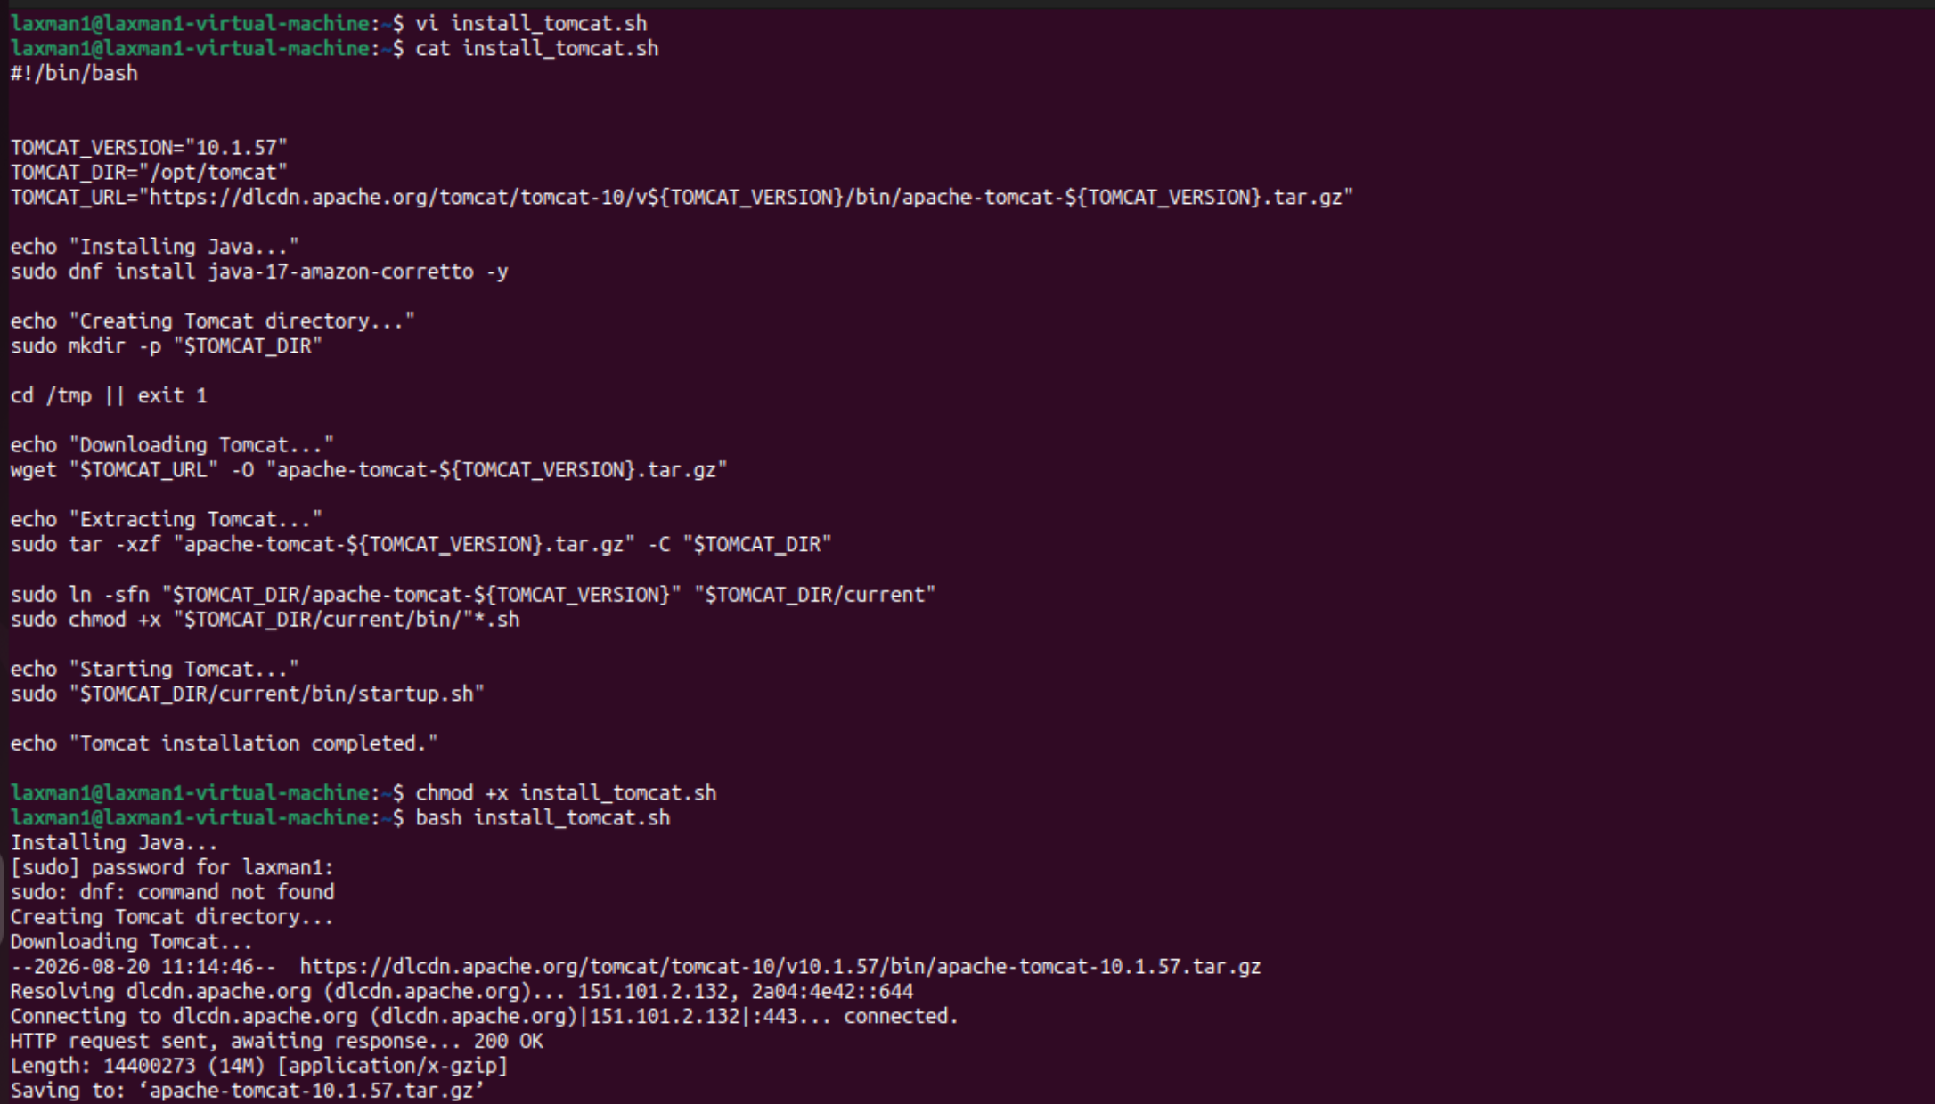
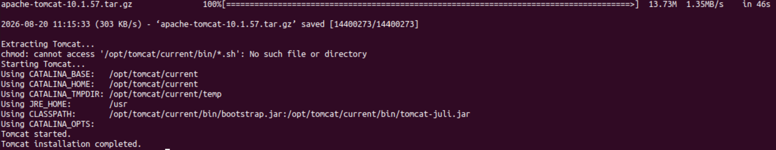

6. Check NGINX Service and Start It if Not Running
Script file: check_nginx.sh
Purpose: systemctl is-active checks the service state. If inactive, the script starts NGINX.
#!/bin/bash
if systemctl is-active --quiet nginx
then
echo "NGINX service is running."
else
echo "NGINX service is not running."
echo "Starting NGINX..."
sudo systemctl start nginx
if systemctl is-active --quiet nginx
then
echo "NGINX started successfully."
else
echo "Failed to start NGINX."
fi
fi
Execute: chmod +x check_nginx.sh
Run: ./check_nginx.sh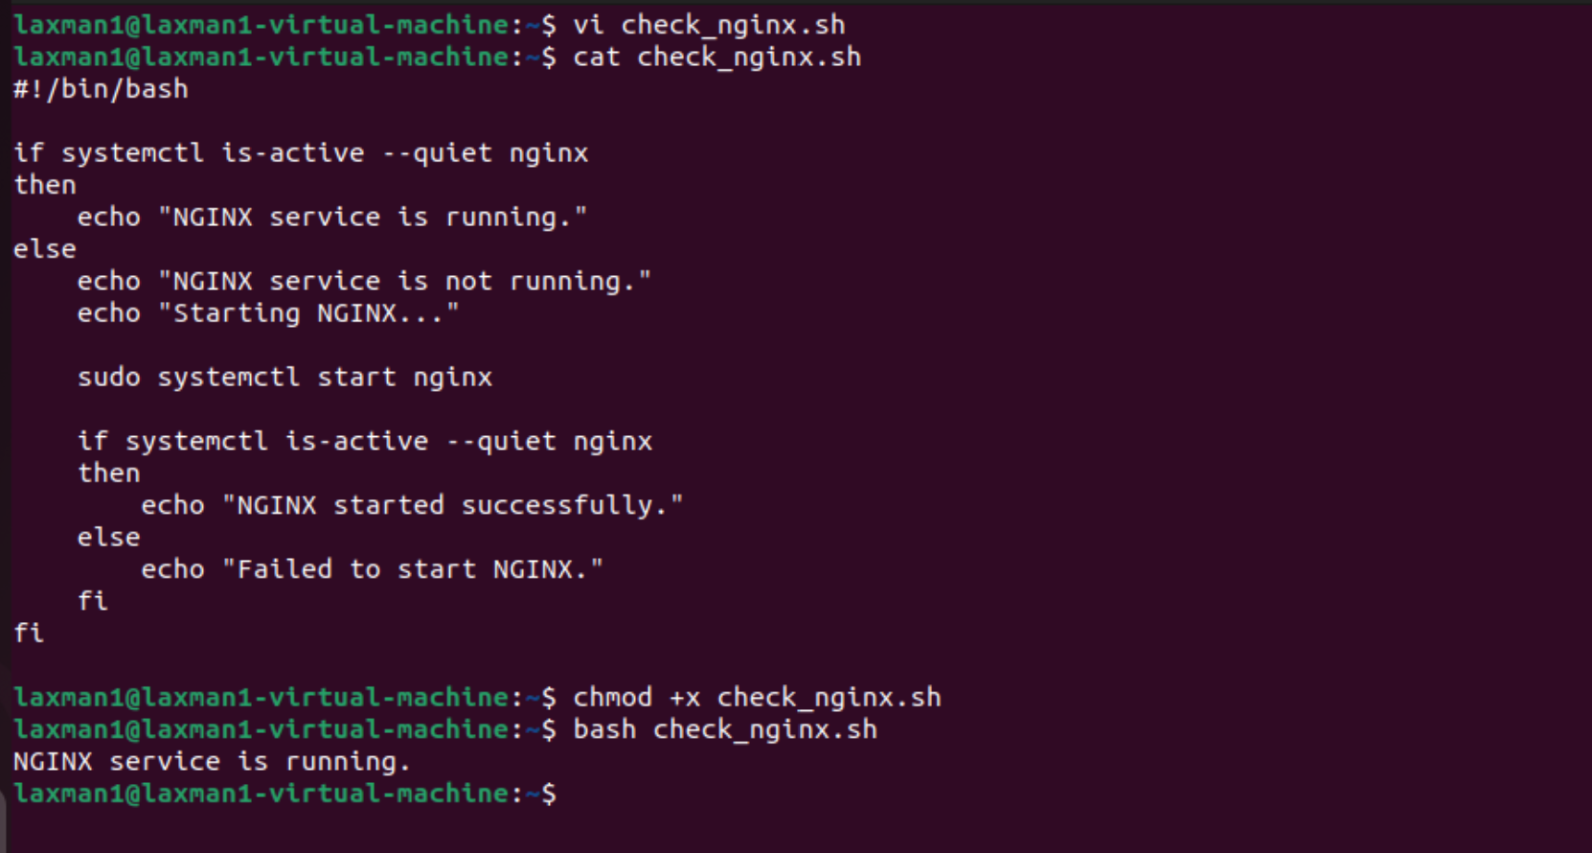

7. Create a Directory if It Does Not Exist
Script file: create_directory.sh
Purpose: The script checks the directory with -d and creates it with mkdir -p when missing.
#!/bin/bash
DIR="/home/laxman1"
if [ -d "$DIR" ]
then
echo "Directory already exists: $DIR"
else
echo "Directory does not exist."
echo "Creating directory..."
mkdir -p "$DIR"
if [ $? -eq 0 ]
then
echo "Directory created successfully: $DIR"
else
echo "Failed to create directory."
fi
fi
Execute: chmod +x create_directory.sh
Run: ./create_directory.sh
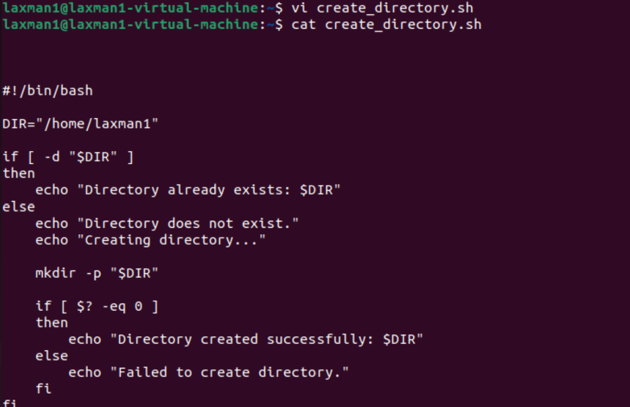
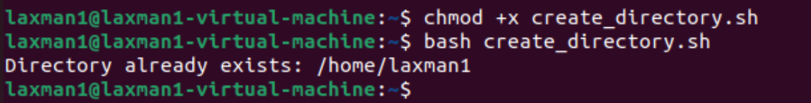

8. Delete the Last 3 Lines from a File
Script file: delete_last_3_lines.sh
Purpose: head -n -3 keeps every line except the final three lines and replaces the original file.
#!/bin/bash
FILE="/home/laxman1/test"
if [ ! -f "$FILE" ]
then
echo "File does not exist: $FILE"
exit 1
fi
LINES=$(wc -l < "$FILE")
if [ "$LINES" -le 3 ]
then
: > "$FILE"
echo "File contained 3 or fewer lines; it is now empty."
else
head -n -3 "$FILE" > "$FILE.tmp" && mv "$FILE.tmp" "$FILE"
echo "Last 3 lines deleted successfully."
fi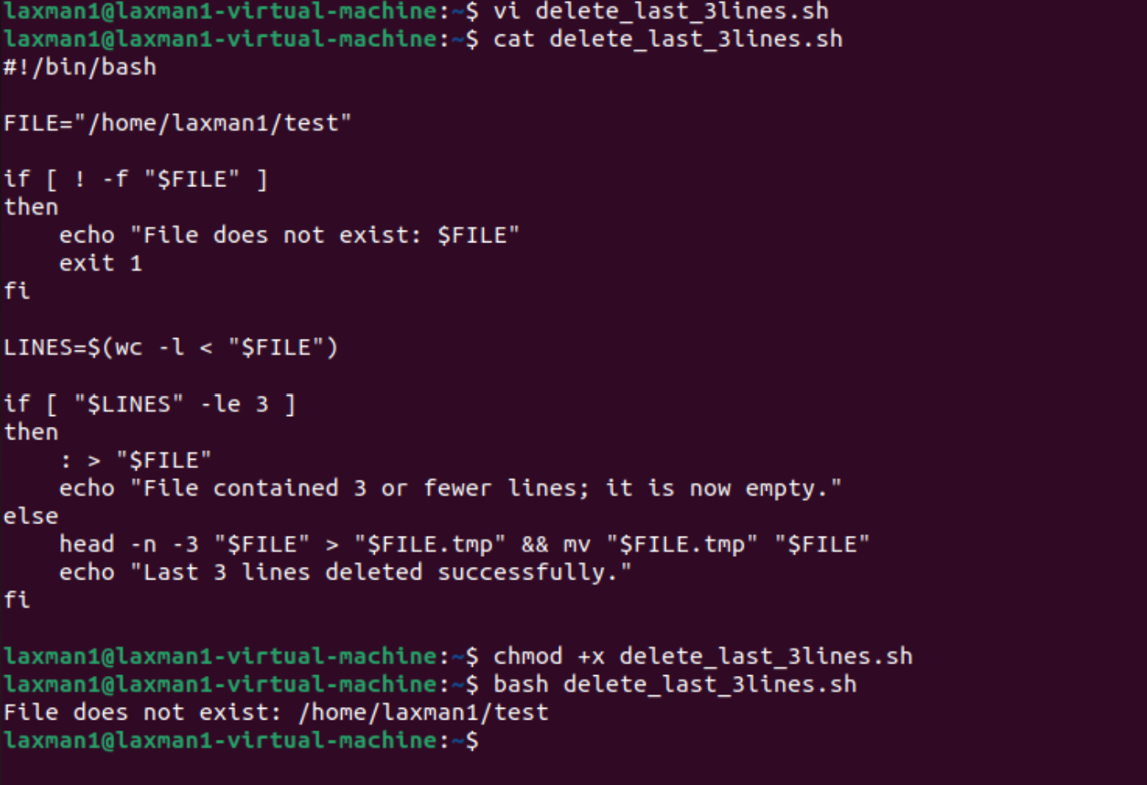
Execute: chmod +x delete_last_3_lines.sh
Run: ./delete_last_3_lines.sh

9. Monitor CPU Usage and Send Email if Above 80%
Script file: monitor_cpu.sh
Purpose: The script calculates CPU usage and sends an email when it exceeds 80%. A working mail service is required.
#!/bin/bash
THRESHOLD=80
EMAIL="admin@example.com"
CPU_IDLE=$(top -bn1 | awk '/Cpu\(s\)/ {print $8}')
CPU_USAGE=$(awk "BEGIN {printf \"%.0f\", 100 - $CPU_IDLE}")
echo "CPU Usage: ${CPU_USAGE}%"
if [ "$CPU_USAGE" -gt "$THRESHOLD" ]
then
echo "CPU usage is above ${THRESHOLD}%." | mail -s "CPU Alert" "$EMAIL"
echo "Email notification sent."
else
echo "CPU usage is within the limit."
fi
Execute: chmod +x monitor_cpu.sh
Run: ./monitor_cpu.sh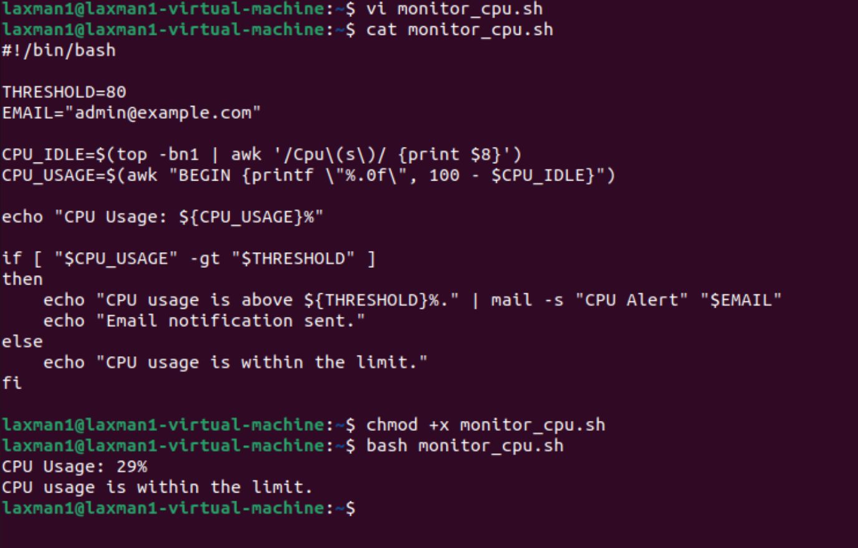

10. Monitor Disk Space and Send Email if Above 80%
Script file: monitor_disk.sh
Purpose: The df command checks filesystem usage. This example monitors the root filesystem.
#!/bin/bash
THRESHOLD=80
EMAIL="laxmankumar555999@gmail.com"
DISK_USAGE=$(df -P / | awk 'NR==2 {gsub("%","",$5); print $5}')
echo "Disk Usage: ${DISK_USAGE}%"
if [ "$DISK_USAGE" -gt "$THRESHOLD" ]
then
echo "Disk usage is above ${THRESHOLD}%." | mail -s "Disk Space Alert" "$EMAIL"
echo "Email notification sent."
else
echo "Disk usage is within the limit."
fi
Execute: chmod +x monitor_disk.sh
Run: ./monitor_disk.sh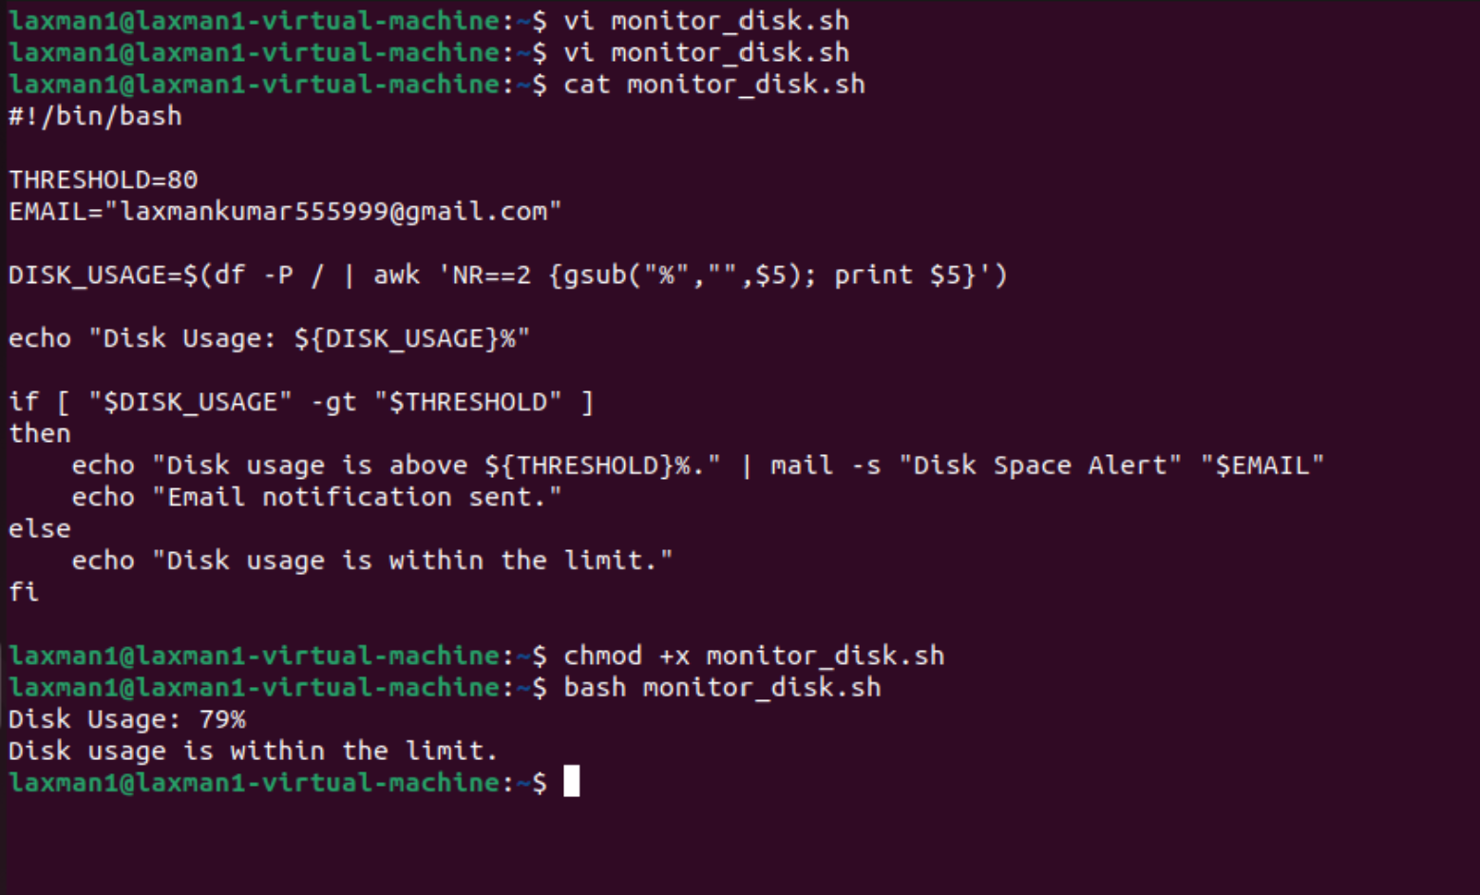

11. Monitor Memory Usage and Send Email if Above 80%
Script file: monitor_memory.sh
Purpose: The free command provides memory statistics. The script calculates used memory percentage and sends an email above 80%.
#!/bin/bash
THRESHOLD=80
EMAIL="laxmankumar555999@gmail.com"
MEM_USAGE=$(free | awk '/Mem:/ {printf "%.0f", ($3/$2)*100}')
echo "Memory Usage: ${MEM_USAGE}%"
if [ "$MEM_USAGE" -gt "$THRESHOLD" ]
then
echo "Memory usage is above ${THRESHOLD}%." | mail -s "Memory Alert" "$EMAIL"
echo "Email notification sent."
else
echo "Memory usage is within the limit."
fi
Execute: chmod +x monitor_memory.sh
Run: ./monitor_memory.sh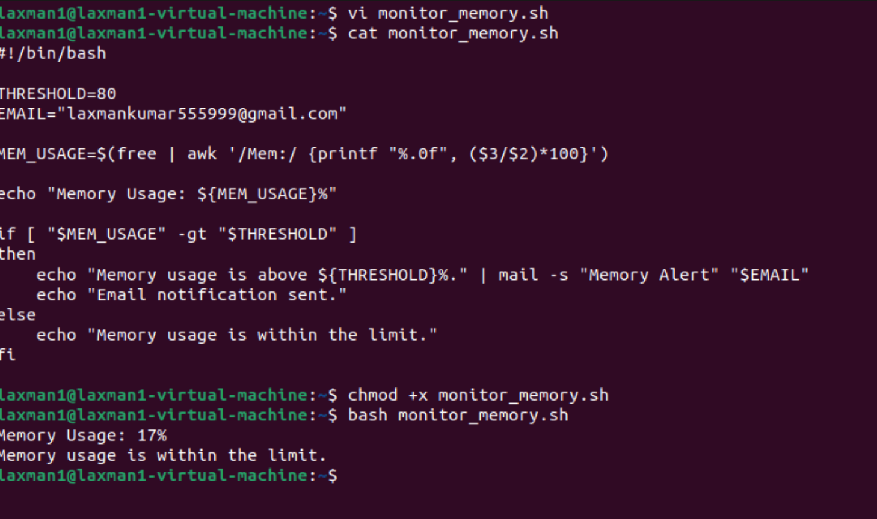

Email Notification Setup
The monitoring scripts use the mail command. A working mail utility and SMTP/mail service must be configured before email alerts will work.
- Replace admin@example.com with the required recipient.
- Test email delivery before relying on automated alerts.
- Never place passwords, SMTP credentials, API keys, or private keys directly in scripts.

Useful Commands
bash -n script.sh — Check Bash syntax without executing the script.
chmod +x script.sh — Give execute permission.
./script.sh — Execute the script.
systemctl status nginx — Check NGINX status.
df -h — Display disk usage.
free -h — Display memory usage.
top — Display CPU and process information.

Important Notes
- Review scripts before running commands with sudo privileges.
- Test scripts in a lab environment before production use.
- The NGINX installation example uses dnf and is intended for Amazon Linux.
- Ubuntu uses apt instead of dnf for package installation.
- Tomcat versions and download URLs can change; verify the current official release before installing.
- For production monitoring, add logging, error handling, and appropriate alert management.

Practical Submission Checklist
- Directory availability script created and tested.
- Multiple-file creation script created and tested.
- Directory backup script created and tested.
- NGINX installation script created and tested.
- Apache Tomcat installation script created and tested.
- NGINX service monitoring script created and tested.
- Directory creation script created and tested.
- Last 3 lines deletion script created and tested.
- CPU monitoring script created and tested.
- Disk monitoring script created and tested.
- Memory monitoring script created and tested.
- Screenshots collected where required.

